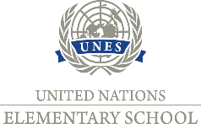 Private Elementary School UNES, Javorová 12/644, Nitra
Invitation to a parents' meeting of future first graders
Dear parents,
We would like to kindly invite you to a friendly and informational meeting. We want to inform you about the current educational program, after-school activities, school club for children, uniforms, contracts and answer any questions you may have about teaching and school operation.
The first meeting of parents will take place on May 26 (Wednesday) at 3 pm in the Elementary school (laboratory, next to the gym).

We look forward to your participation!

